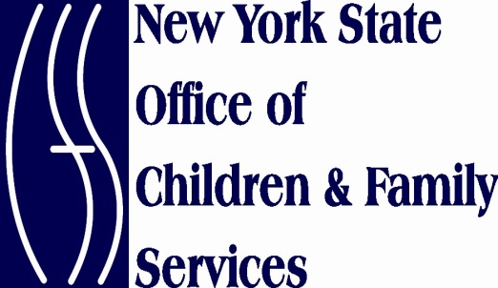 April, 2011

Dear Colleague:

A number of important changes and reminders are contained in this letter. Please read the information carefully and contact your Regional Office licensor or registrar with any questions you may have.

C:\Users\90a380\AppData\Local\Microsoft\Windows\Temporary Internet Files\Content.IE5\FK84OPYY\MC900389724[1].wmf

**State Central Register $25.00 Fee for Database Checks – EFFECTIVE IMMEDIATELY**

The new State budget includes an amendment to Section 424-a(1)(f) of the Social Services Law, which sets forth requirements for fees for conducting database checks through the Statewide Central Register of Child Abuse and Maltreatment (SCR). The change in the law now requires that prospective child care providers and applicants for employment in child care programs be charged a $25 fee for any database checks conducted through the SCR. **This change took effect on Friday, April 1, 2011.**

Please note that the fee requirements do not apply to volunteers who will work in child care programs, nor do they apply to providers of goods and services to child care programs, consultants to child care programs, or to current employees who have previously been screened through the SCR if the program elects to re-screen current employees. The fee requirements also do not apply to persons age 18 or over who reside in homes where family and group family child care will be provided, unless the household member is also employed at the program as a substitute, alternate provider, assistant, alternate assistant or other paid caretaker.

Please note that there are references below to a “payment of the fee.” There are four methods of acceptable payment of the fee. These are:

1. Certified check;
2. Postal or bank money order;
3. Teller’s check; or
4. Cashier’s check

**\*Personal checks are not acceptable and will be returned and your application will not be processed until an acceptable form of payment is received.**

Each must be made payable to: **NEW YORK STATE OFFICE OF CHILDREN AND FAMILY SERVICES**.

**Family Day Care Homes:** When applicants to be family day care providers or to be assistant or alternate caregivers in family child care homes submit their application materials to the regional office of OCFS or to the registrar for their county (which would be a child care resource and referral program, a local social services district or, for homes in New York City, the New York City Department of Health and Mental Hygiene), they will be required to submit a payment of the fee in the amount of $25 for the required database check. The payment of the fee must include the name of the applicant so that it may be properly processed. The application will not be processed without the required payment of the fee. Please note that there must be a separate payment of the fee for each applicant.

**Group Family Day Care Homes:** When applicants to be group family day care providers or assistants or alternate caregivers in group family day care homes submit their application materials to the regional office of OCFS (or, for homes in New York City, the New York City Department of Health and Mental Hygiene), they will be required to submit a payment of the fee in the amount of $25 for the required database check. The payment of the fee must include the name of the applicant so that it may be properly processed. The application will not be processed without the required payment of the fee. Please note that there must be a separate payment of the fee for each applicant for whom a LDSS-3370 form is submitted.

It is important to understand that this **amendment does not change who must be cleared by the SCR, just who must pay a fee to be cleared by the SCR.** For additional information concerning who must be cleared by the SCR, see policy 06-7 at: [**http://www.ocfs.state.ny.us/main/becs/policy/default.asp**](http://www.ocfs.state.ny.us/main/becs/policy/default.asp)**,** or contact your Regional Office.

 The Statewide Central Register Database Check Form, or LDSS-3370, is a form completed by applicants who are screened by the New York State Statewide Central Register (SCR), to determine whether they are the subject of indicated reports of child abuse or maltreatment on file with the SCR. These forms need to be filled out completely and accurately to result in an accurate report.

**Getting it Right - Who to Include on the SCR Database Check Form**

The form asks for two different pieces of major information:

* Applicant and household member information and
* Addresses for where the applicant has resided.

**ALL household members, both adults and children, whether they are related to the applicant or not, need to be listed on the LDSS-3370 form.** It’s important to remember to list all maiden names and aliases as well. This is because the SCR specialist must search all names provided. Each name is searched individually and as part of a household composition. This is because sometimes an individual’s name is not found immediately, but is later discovered through the matching of another person and a family composition. When information is left out, the search is not accurate and the provider may be hiring a person with a CPS history because they failed to complete the form as directed.

If you submit a form with just one name on it because you live alone, write the word “NONE” in the applicant/household area of the form after entering your own information.

For screening purposes, the form also requires information about the applicant’s current and previous addresses. Addresses must go back as far as 28 years. The SCR staff understands that some people may find it difficult to provide complete detailed information about address history for their childhood years. So, have applicants do their best when completing this portion of the form by providing at least the name of the city and state in which they lived for each time period, even if you don’t know a street number or street name. Remember, the more information the SCR gets, the better the search and the quicker the return.

 If you are planning to take on-line course work to meet your thirty-hours of required training, please be reminded that all on-line training must be pre-approved by the Office of Children and Family Services (OCFS). A list of pre-approved distance learning courses can be found at the following website address: <http://www.tsg.suny.edu/ocfsdlc.shtm>. This list includes all pre-approved on-line CPR training courses that include face-to-face competency tests. OCFS also offers a growing number of E-Learning courses for credit toward your thirty-hour training requirement. This list can be found at: <http://www.ecetp.pdp.albany.edu/elearn_catalog.shtm>.

**Reminder: All On-line Training Must be Pre-Approved**

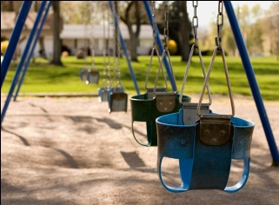 After much consideration and deliberation concerning protective surfacing under playground equipment, OCFS believes it has found a way to address child safety and enable you, the provider, to offer fun, outdoor play experiences for the children in family-based programs, at a reasonable cost while meeting regulatory compliance.

**A New Approach - Playground Surfacing**

***Compliance with family and group family day care regulations concerning outdoor playground equipment and surfacing will include the following requirements:***

* ***Materials and play equipment used by the children must be sturdy, free from rough edges and sharp corners.***
* ***Outdoor equipment such as swings, slides and climbing apparatus must be assembled in accordance with the manufacturer's specifications, and there must be a cushioned surface under all outside play equipment that present a fall hazard. Surfacing may not include concrete, asphalt, grass or other hard compacted dirt. Equipment must be in good repair and be placed in a safe location. Residential outdoor play equipment manufactured for home use may be used by children in family-based programs and must be used specifically for its intended purpose. Such equipment and apparatus may be used only by the children for whom it is developmentally appropriate.***

*The document currently posted to our website named*: ***Protective Surfacing under Playground Equipment used at Family- Based Child Care Programs:***<http://www.ocfs.state.ny.us/main/childcare/Protective_Surfacing.asp> will remain a best practice instructional guide. The language above will be posted on the website as well.

Be proactive—visit the child care webpage for the ***Residential Pool Guidelines*** at: <http://www.ocfs.state.ny.us/main/childcare/pool_guidelines.asp#regs>.

**If Spring is Here - Can Summer be Far Behind?**

I hope this information is helpful. Thank you for your commitment to safety and all that you do for the children of New York State.

Sincerely,

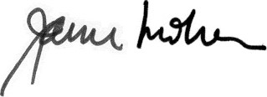

Janice M. Molnar, Ph.D.

Deputy Commissioner

Division of Child Care Services