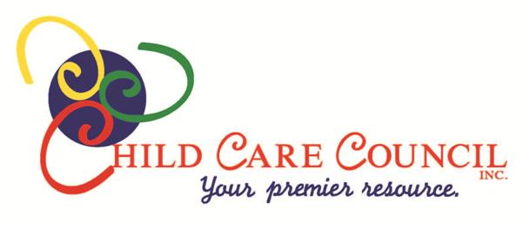
Job Posting: Child Care Health Consultant
Child Care Council Inc. is pleased to announce an opening for a Child Care Health Consultant to provide consultative services, technical assistance, and health training to individuals who are caring for young children in family and group family child care homes, child care centers, and school age child care classrooms in Monroe, Livingston, and Wayne counties. The Child Care Health Consultant’s role includes, but is not limited to, approving child care program policies and procedures regarding medication administration, child special health care needs, infection control, and emergency plans in accordance with NYS Child Day Care regulations and best practice standards, training child care providers in the Medication Administration Training (MAT), developing and presenting adult educational programs to large and small group settings, and providing individualized technical assistance and support to caregivers and parents as needed. Requirements:
• Current NYS license as a Registered Professional Nurse - Bachelor’s Degree required
• Minimum of 3 years work experience in the health care field including working with children and/or families
• Clean driving record and daily use of a reliable vehicle
• Willingness to drive throughout Monroe, Wayne, and Livingston counties in all seasons
• Excellent verbal and written communication skills
• Experience making presentations to groups of adult learners
• Working knowledge of computers and internet
35 hour week including some evenings and Saturdays
Excellent Benefits including:
• 90% single coverage Health Insurance with Excellus Blue Cross
• Dental Insurance coverage
• Life Insurance equal to one year’s salary
• Free Parking
• Mileage reimbursement at government rate
• 403B Retirement Pan
• Flex Spending Account
• Short and Long Term Disability Insurance
- Paid holidays and vacation days
• Family Friendly work environment
• AAA Membership
• Free Coffee and Tea
Child Care Council Inc. is an Equal Opportunity Employer
Please send resume:
To: Child Care Council, Inc. c/o Kristin Perrone
595 Blossom Road, Suite 120
Rochester, New York 14610-1825 or email to k.perrone@childcarecouncil.com

